|  |
| --- |
|  |

TPPP | Teen Pregnancy & Prevention Partnership

St. Louis-Area Sex Education:

**Evaluation Report**  
Lucy Puckett, Brown School of Social Work   
April 24, 2019

Policies

Practices Experiences

|  |
| --- |
| Executive Summary |
| The Purpose of this evaluation was to update the Teen Pregnancy and Prevention Partnership’s (TPPP) knowledge of current sex education ***policy*** in St. Louis-area public school districts, and to obtain a youth perspective on sex education ***practices*** and ***experiences***. The findings aim to inform TPPP’s district-level professional development offerings and policy advocacy in the St. Louis region, and to support community stakeholders’ efforts to achieve comprehensive sex education as the standard in all Missouri schools.  Key Questions: Practices   1. What sexual health education topics do teens in St. Louis-area public schools report being taught, and to what extent?   *Experiences*   1. What are teens’ experiences of sex education in a St. Louis-area public school?   Policies   1. What sexual health topics are mandated in districts’ sex education policies? 2. What districts need to update their sex education policies based on new, statewide policy and the National Sexuality Education Standards (NSES)?   **Data were collected** using a survey (YPSE) distributed to youth participants of Planned Parenthood’s Teen Advocates for Sexual Health (TASH) program, who shared the survey with their peers. The survey asked teens what topics they were taught in a St. Louis-area public school sex education class and to what extent, and about their experience of the sex education they received. Sex education policies from each district identified in the YPSE survey were reviewed to determine which topics each policy covered, and if the policy met Missouri Sex Education Policy (MSEP) and the NSES.  Key Findings:   * St. Louis teens expressed disappointment with the sex education they received, noted the power of the teacher to determine the quality and content of sex education, and reported learning very little about LGBTQ+ topics or topics related to consent and healthy relationships. They also reported wanting to learn more about those topics. Participants expressed a desire for more time spent on sex education in schools and greater depth of content. * Students who attended schools with comprehensive sex education policies and curricular frameworks reported learning about more in their sex education classes. * No schools met NSES, and only three of nine districts analyzed met MSEP. All districts covered abstinence, STDs/HIV, and conflict management. Only one school covered LGBTQ+ topics, another school covered gender identity, and another school covered healthy relationships.   Recommendations:  1) Implement teacher-training on consent, LGBTQ+ topics, and sexual health facilitation skills. 2) Advocate for comprehensive sex education policy and curricula 3) Target district-level policy advocacy to schools who meet few of the MSEP and NSES mandates. 4) Present findings and participant quotes to legislators, stakeholders, and school administrations, along with recommendations to improve statewide sex education. policy. |
|  |

|  |
| --- |
| Results |
| Participant Characteristics **YPSE Survey.** A total of 81 participants from 28 different St. Louis-area public schools completed the survey. All teens who received the survey completed it, representing a 100% response rate. 26 surveys were excluded from analysis because those participants had never received sex education in a St. Louis-area public school. The remaining 55 surveys represented eight St. Louis-area public school districts and one charter school (see Table 1). All 81 surveys were used to analyze answers to the question, “How important do you think it is for teens to have sex ed?”—regardless of whether the participants ever received sex education in a St. Louis-area public school. Most participants were in high school (n=78) and the remaining three were in the eighth grade. The most commonly attended schools were Ladue Horton Watkins High School in the Ladue School District (n=18) and Webster Groves High School in the Webster Groves School District (n=16).  **SDSEP Matrix.** Based on 2016-2017 student enrollment numbers, the largest school districts analyzed were St. Louis Public School District (21,754 students), Rockwood R-VI School District (20,952 students), and Parkway C-2 School District (17,434 students). Kirkwood R-VII School District had an enrollment of 5,708 students. All other districts had enrollment of under 5,000 students (Ladue School District, Normandy Schools Collaborative, Clayton School District, and Webster Groves School District. The smallest district was Confluence Charter Schools, with 735 students enrolled (See Table 1). |
| Table 1 Participant School Districts |

|  |
| --- |
| *Evaluation Questions*  Practices  1. What sexual health education topics do teens in St. Louis-area public schools report being taught, and to what extent? All 20 topics listed in the survey were reported as being taught at least “a little bit.” See Figure 1, Topic Frequency.   **Topics Taught the Least:** Topics reported as being taught the least were human trafficking, gender identity, and LGBTQ+ topics—with a vast majority of participants reporting being taught “nothing” about those topics. 50.9% of participants reported being taught “nothing” about the consequences of sexting, and almost half of participants reported being taught “nothing” about sexual violence (49%) and how to use condoms (47.7%).  **Topics Taught the Most:** All participants reported being taught about STDs, abstinence, and how pregnancy happens. More than half of participants reported being taught “a good amount” about STDs (80%), abstinence (76%), puberty (67%), how pregnancy happens (63%), the consequences of teen pregnancy (61%), and HIV/AIDS (61%). Other high-scoring topics included reproductive anatomy (40% of participants reported learning “a good amount”) and healthy relationships (50% of participants reported learning “a good amount”). 11 participants (20%) reported being taught “a good amount” about birth control and consent. |
|  |
| Figure Topic Frequency  Figure Topic Frequency |

|  |
| --- |
| Experiences 2. What are teens’ experiences of sex education in a St. Louis-area public school? ***Satisfaction.* YPSE Question: *“How satisfied were you with the sex education you received in a St. Louis-area public school?”***Of the 81 participants, 26% (n=15) reported being not at all satisfied with the sex education they received, 40% (n=23) reported being a little satisfied*;* 22% (n=13) reported being somewhat satisfied, 9% (n=5) reported being satisfied, and only 3% (n=2) reported being very satisfied. ***Learning.* YPSE Question: *“Were there any topics you wished you’d learned more about?”*** Participants most frequently mentioned wanting to learn more about LGBTQ+ topics (n=21). Other topics included consent (n=17), communication (n=17), and birth control (n=9). Ten participants (18%) simply reported that they wanted to learn “a lot more” (See Figure 2). |
|  |
| Figure 2 Sex Ed Topics Teens Wanted to learn More About  Figure  Figure |

***Learning.* YPSE Question**: ***“Was there anything you learned in your sex ed class in a St. Louis-area public school that was really helpful?”*** 18 participants (32%) reported that nothing they learned in their sex education class was helpful. 16 (29%) participants reported learning helpful information about STDs. Other helpful topics included birth control/pregnancy prevention (14%), healthy relationships (7%), and reproductive anatomy (7%). Only 3% of participants reported learning helpful information about menstruation, pregnancy itself (not pregnancy prevention), and consent. One participant reported puberty, and one participant reported abstinence as being helpful topics (see Figure 3).

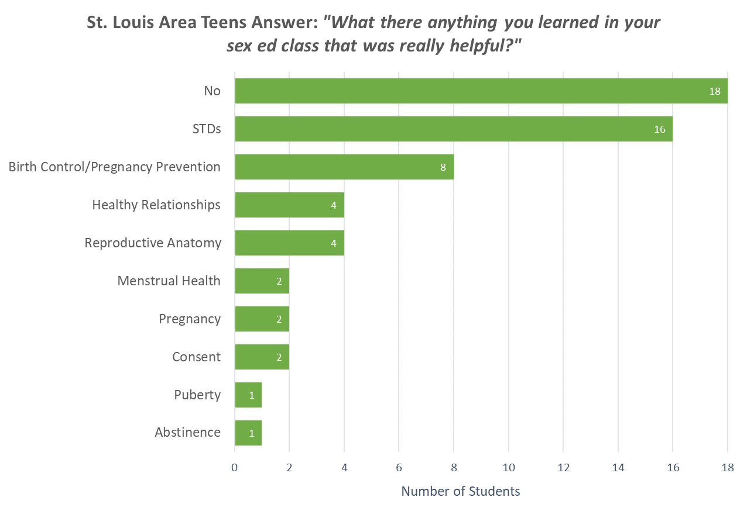

Figure 3 Sex Education Topics Reported as Being Helpful

***Importance.* YPSE Question:** ***“How important do you think it is for teens to receive sex education?”*** Seven percent of participants said that sex education was “important.” Ninety three percent (n=75) said that sex education was “very important.” See Figure 4.

**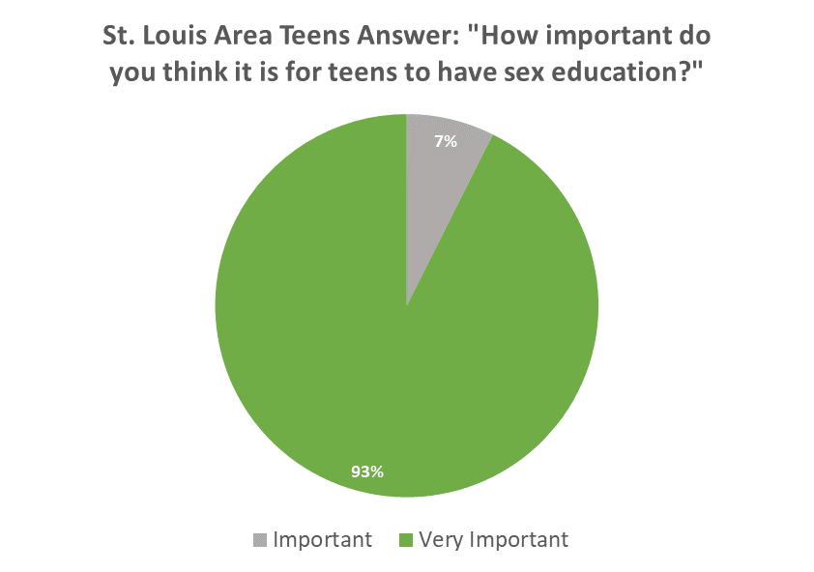  
*General*.** **YPSE Question: *“Is there anything else you would like to say about your experience with sex ed in a St. Louis-area public school?”*** Among the 28 participants that answered this YPSE survey question, most respondents expressed disappointment (81%). Six themes emerged through analysis: frustration or emotion in answer (38% of answers); the power of the teacher (23% of answers); desire for more in-depth content (38% of answers); a general expression of wanting sex education to “be better” (38% of answers); frustration with abstinence-only sex education (19% of answers); and a need for LGBTQ+ inclusion (15% of answers). See Table 2 for a detailed description of each theme. See Appendix B, Table B1 for participant quotes taken from the YPSE survey.

Figure 4 Teens Rate Importance of Sex Education

"I wish it taught me more about abusive relationships and what to do when you're in them. We learned the basic and stereotypical warnings, but it goes so much deeper than that. I could've gotten out a lot sooner. More resources are needed."

- Rockwood District,   
 YPSE Survey Participant

Policies  
3. What sexual health topics are mandated in districts’ sex education policies?**All school districts listed STDs and HIV; Conflict Management, Personal Responsibility, and Self-esteem; and Abstinence in their sex education policy or curriculum. Eight of the nine districts listed Online Safety; Emotional and Psychological Consequences of Adolescent Sexuality, Contraception, and Consequences of Teen Pregnancy in their policies. Seven district policies listed Personal Safety and Legal Responsibility to Children Born out of Wedlock. Only four policies included Sexual Harassment, which is an MSEP standard. Three policies included Consequence of Sexting and Consent. Two district policies listed Puberty and Adolescent Development, Healthy Relationships, and Anatomy and Physiology. Only one district policy included Pregnancy and Reproduction, LGBTQ+ Topics and Gender Identity. No school policy or curriculum included Human Trafficking. (See Table 2, for a visual depiction of topics listed in each districts’ policy.)**

***No school district policies surveyed met the National Sexuality Education Standards***

4. What districts need to update their sex education policies based on new, statewide policy and the National Sexuality Education Standards?

Only three school districts (Confluence Charter Schools, Parkway, and Rockwood) met MSEP standards. All schools with a Missouri School Board (MSB) policy (Clayton, Kirkwood, Ladue and Normandy Schools Collaborative) need to be updated to include section 9 of the MO 170.015, requiring schools who provide sex education to include the topics sexual harassment, sexual violence, and consent. St. Louis City School District policy needs to be updated to include MSEP topics of sexual harassment, sexual violence, and consent, and all topics related to online and digital safety. Webster Groves School District’s sexual health education policy could not be located. The curricular materials analyzed in lieu of a policy had no topics related to consent and sexual violence, online and digital safety, or teen pregnancy. (See Appendix B, Table B3). No school districts surveyed met NSES standards

|  |  |
| --- | --- |
| Table 2 St. Louis-Area Public School Districts’ Sex Education Policy Categories  This chart categorizes the sex education policies of the St. Louis-area public school districts identified in the YPSE survey. Two school districts (Parkway and Webster Groves) did not have Descriptive sex education policies available, so their health curricula were analyzed instead. The evaluators were not able to determine Webster Groves’ categorical scoring based on their available materials.    Implications—*So What?*  Key Implications  Practices  **Teachers.** Teens’ emphasis on the importance of the teacher in determining the quality and content of sexual health education raises an important point. One participant from Parkway School District stated that their teacher chose not to implement the district’s comprehensive sex education curriculum. TPPP supported that district through a lengthy process to update its sexual health education policy and materials. It is important to note that teachers themselves also need support to implement quality sexual health education—even in districts that have up-to-date sex education policies. Other responses noted teachers’ discomfort with talking about sexual subject matter, which students reported impacted their ability to learn. Still, other participants from less-than-comprehensive districts pointed to teachers who were especially effective in sexuality education instruction as improving students’ learning.  **Content.** Topics teens reported wanting to learn about more (LGBTQ+ topics, and topics related to healthy relationships like consent and communication) corresponded to topics teens reported learning about the least and were also some of the lowest scoring topics on the SDSEP Matrix. As of now, LGBTQ+ topics and gender identity are not mandated in Missouri sex education policy, but consent and healthy relationships are.  Experiences  **Not Great.** Teens’ level of emotion in answering open-ended questions about their experience of sex  education conveyed impressive disappointment and frustration. Teens state clearly that they do not feel they are getting what they need to practice healthy sexuality. Results suggest that teens want and expect more content and more depth of content from their in-school sex education.    Policies  **Districts**. Results show that all districts, other than Parkway, need significant work to become up to date with Missouri state sex education policy—much less the National Sexuality Education Standards. SLPS and Webster Groves need the most support, with policies that only include seven topics of the SDSEP matrix. Other districts in highest need of policy revision are Clayton, Kirkwood, Ladue, and Normandy School Collaboratives. Results also reveal the importance of comprehensive sex education policy—even if it is not implemented perfectly. The districts with the most comprehensive policies also had high-frequency reports by YPSE participants of topics taught. | |
|  | |
| |  | | --- | | Community Recommendations—*Now What?*  Practices   * **Teachers need education.**   Teachers need more training in general sex education facilitation skills, as evidenced by students’ reports of teachers feeling uncomfortable discussing sexual health subject matter. Parents, teachers, administrators, and stakeholders should advocate for teachers who will be implementing in-school sex education to receive adequate professional development to ensure they are prepared and feel confident addressing sexuality in the classroom. Wide-scale professional development in sexuality education may be challenging since schools have limited budgets for trainings and limited time, and teachers face competing topics of importance. However, Missouri sex education policy has changed twice since 2016 and, as seen through this policy analysis, many districts have not yet updated their policies to match. This gap creates an opportunity for topic-specific professional development on this subject. Highlighting this discrepancy as well as student reports from the YPSE survey can support advocacy efforts. * **Focus on LGBTQ+, gender identity, consent education.** In addition to general sex education facilitation skills, teachers specifically need support on LGBTQ+ topics, healthy relationships, consent, and gender identity. The results of the YPSE survey are supported by research showing that “Healthy Relationships” is considered a controversial sexual health topic and that teachers’ lack of confidence in teaching consent is a barrier to implementation5,6. Further, the GLSEN 2019 Missouri State Snapshot revealed that many students (23%) heard school staff make homophobic remarks or negative comments about someone’s gender expression (44%)7.   Policies   * **Present YPSE results and participant quotes with policy recommendations to legislators.**  Teens’ expressive articulation of their experiences in sex education are meaningful, persuasive data that can be used to leverage policy change towards comprehensive, medically accurate, inclusive sex education in our state. | |  |   Limitations  School districts most heavily represented in the evaluation are in higher-income areas. SLPS, the largest district in the region, was represented minimally. Results offer a limited picture of what sex education is like for a vast majority of St. Louis-area teens.  Members of the TASH program who completed and shared the survey may present a bias towards comprehensive sex education, since they have self-elected to participate in sexual health education advocacy. While there were teens present at the meeting who were not members of TASH, those teens also self-selected to attend the meeting. Further, the sample of this survey is not fully representative or generalizable to all St. Louis-area public school attendees.  References   1. Our Mission. (n.d.). Retrieved February 20, 2019, Retrieved from <https://www.teenpregnancy-mo.org/about-us/mission.html> 2. Community Tool Box, & Center for Community Health and Development at the University of   Kansas. (2018). Participatory Approaches to Planning Community Interventions. Retrieved from  <https://ctb.ku.edu/en/table-of-contents/analyze/where-to-start/participatory-approaches/main>   1. Mo. Rev. Stat. §170.015 (2015). Retrieved from <http://revisor.mo.gov/main/OneChapter.aspx?chapter=170> 2. Future of Sex Education Initiative. (2012). National Sexuality Education Standards: Core   Content and Skills, K-12 [a special publication of the Journal of School Health]. Retrieved from <http://www.futureofsexeducation.org/documents/josh-fose-standards-web.pdf>   1. Donovan, P. (2009, December 06). School-Based Sexuality Education: The Issues and   Challenges. Retrieved from <https://www.guttmacher.org/journals/psrh/1998/07/school-based-sexuality-education-issues-and-challenges>   1. Eisenberg, M. E., Madsen, N., Oliphant, J. A., & Sieving, R. E. (2013). Barriers to Providing the   Sexuality Education That Teachers Believe Students Need. Journal of School Health, 83(5), 335-342. doi:10.1111/josh.1203   1. GLSEN. (2019). School Climate in Missouri (State Snapshot). New York: GLSEN. |
|  |

Appendix A, Instruments

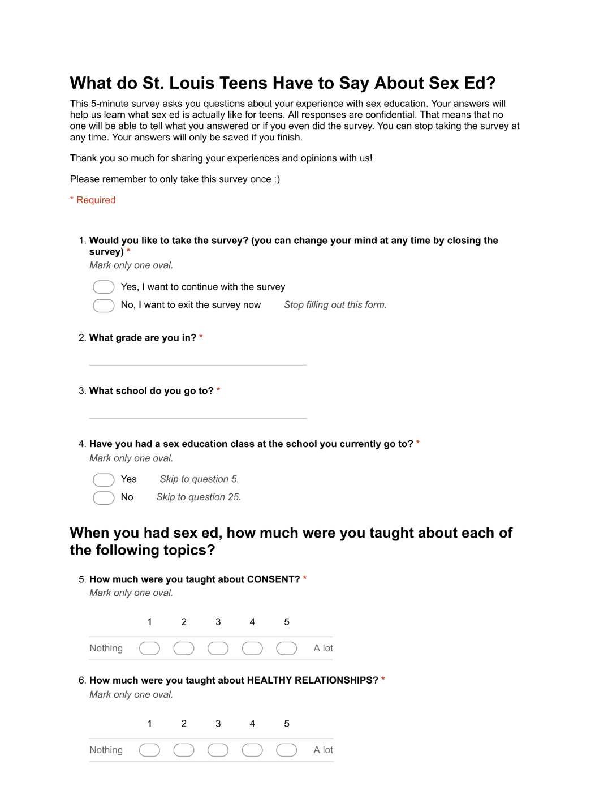YPSE Survey

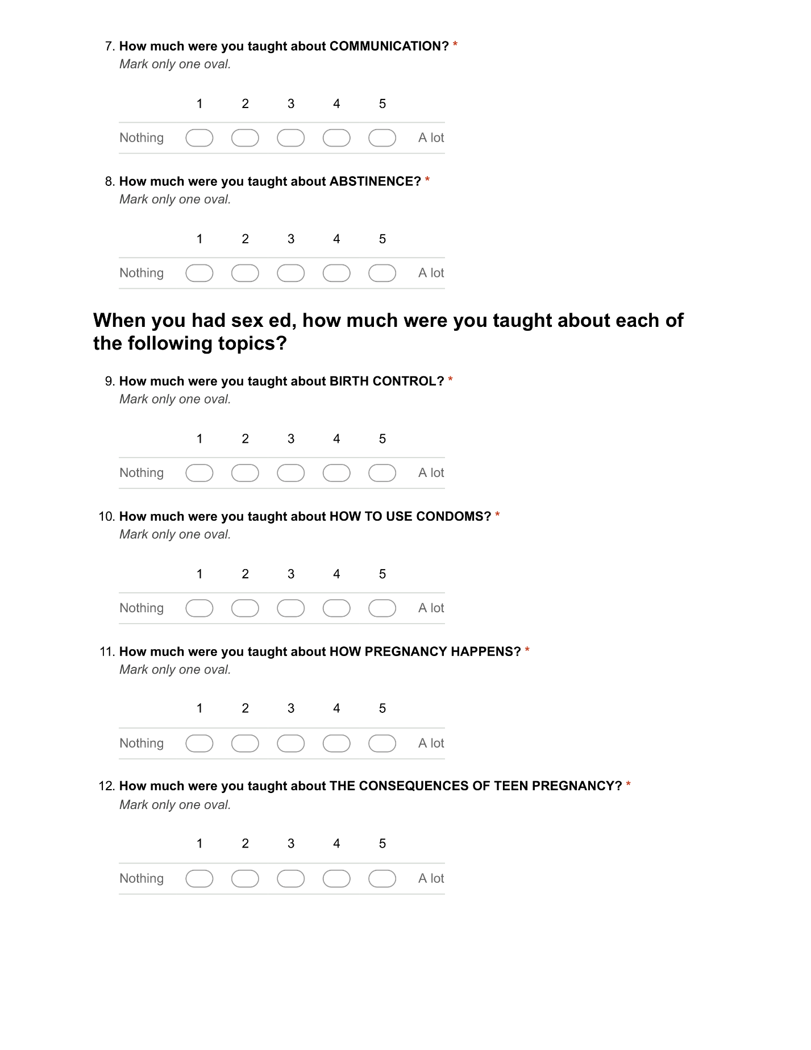

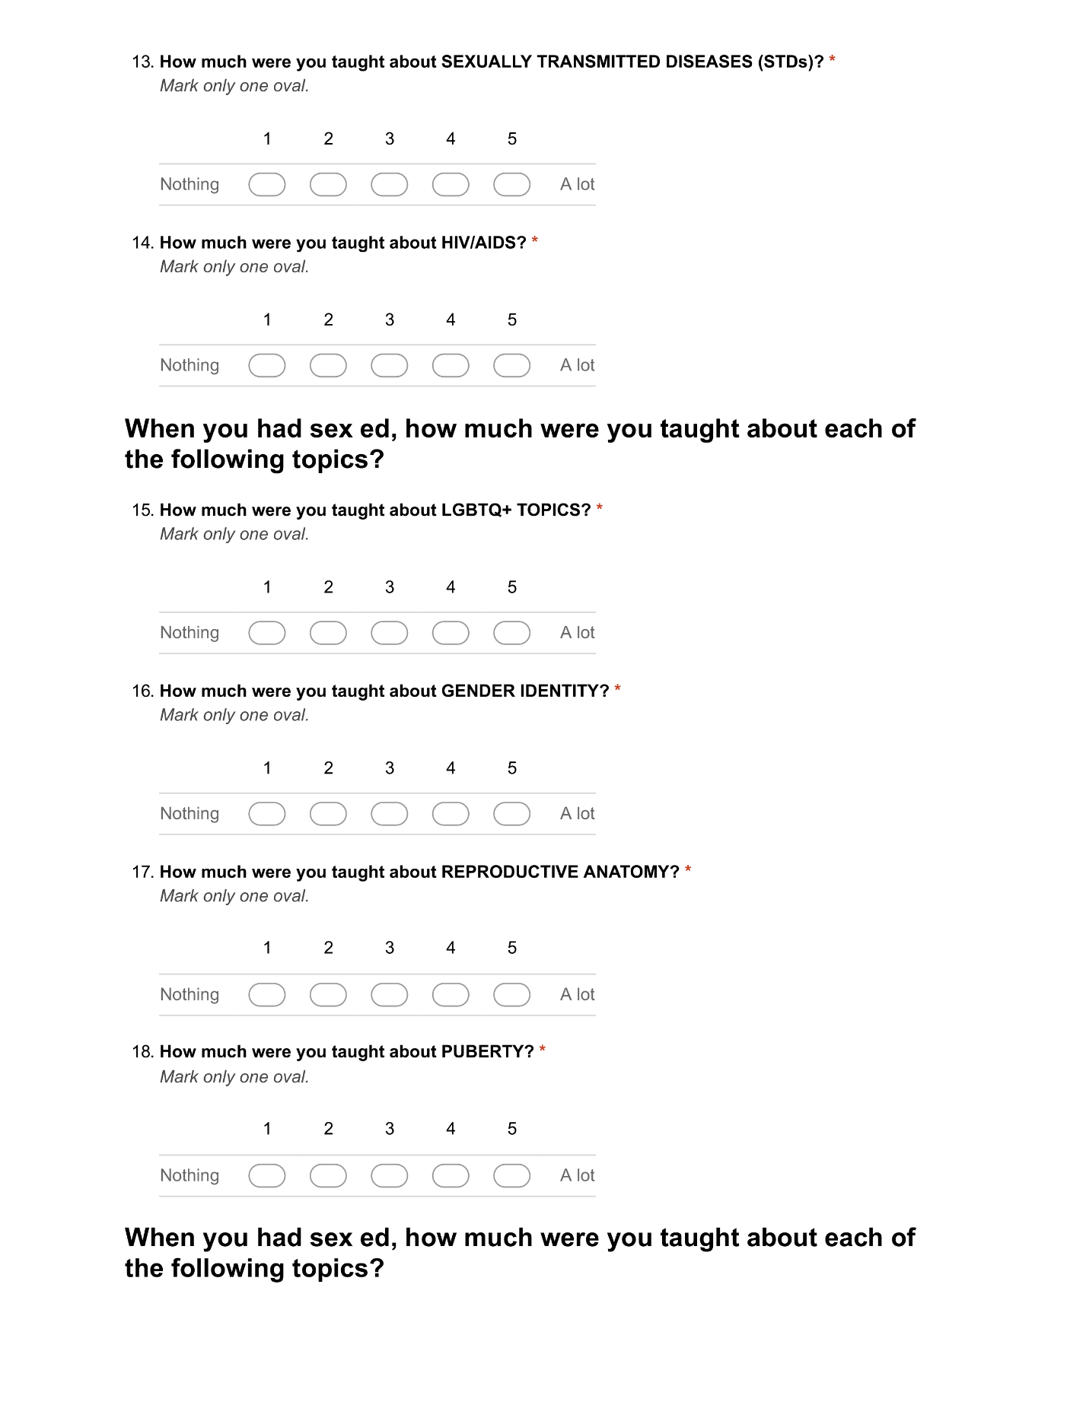



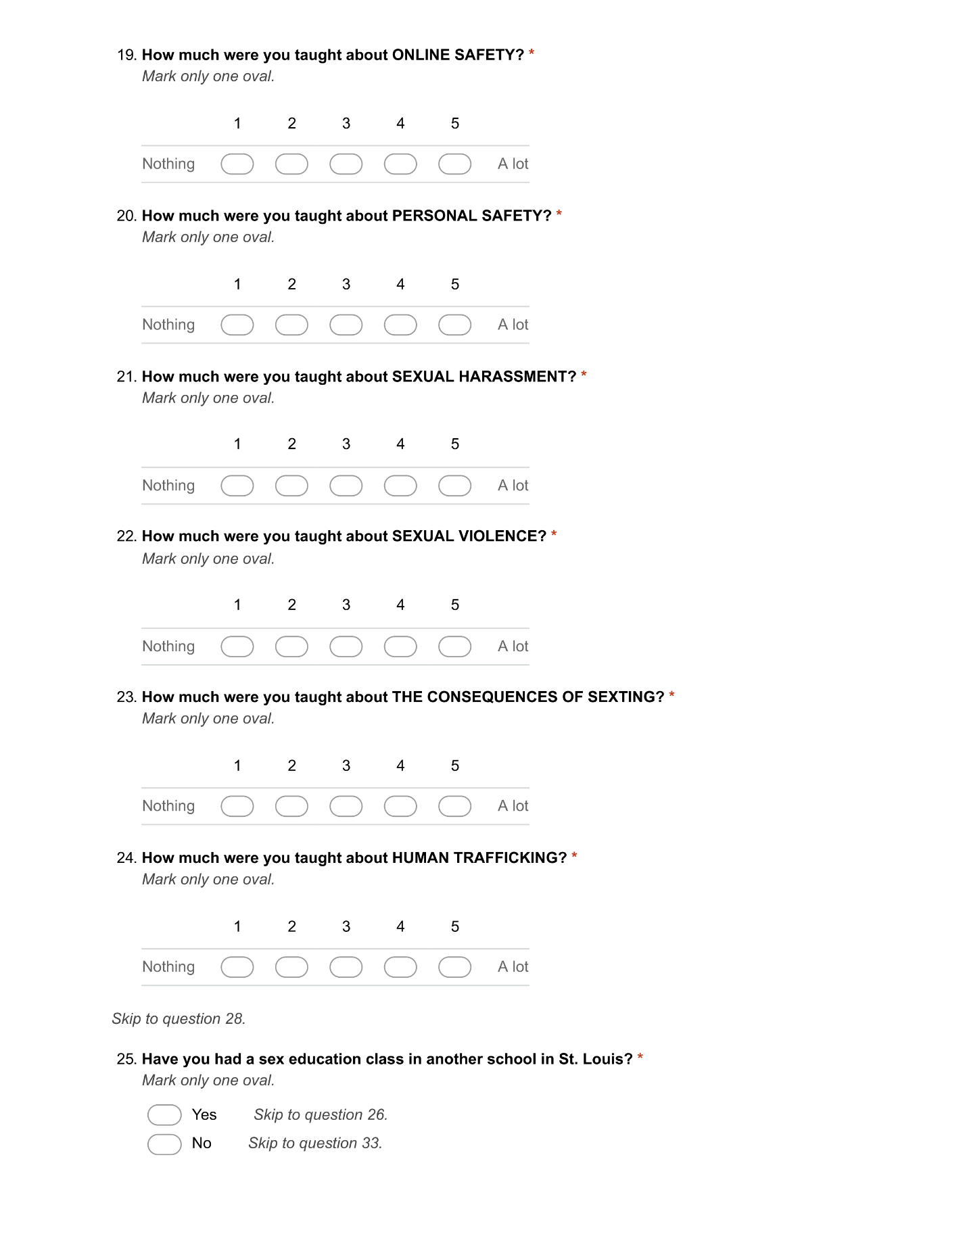



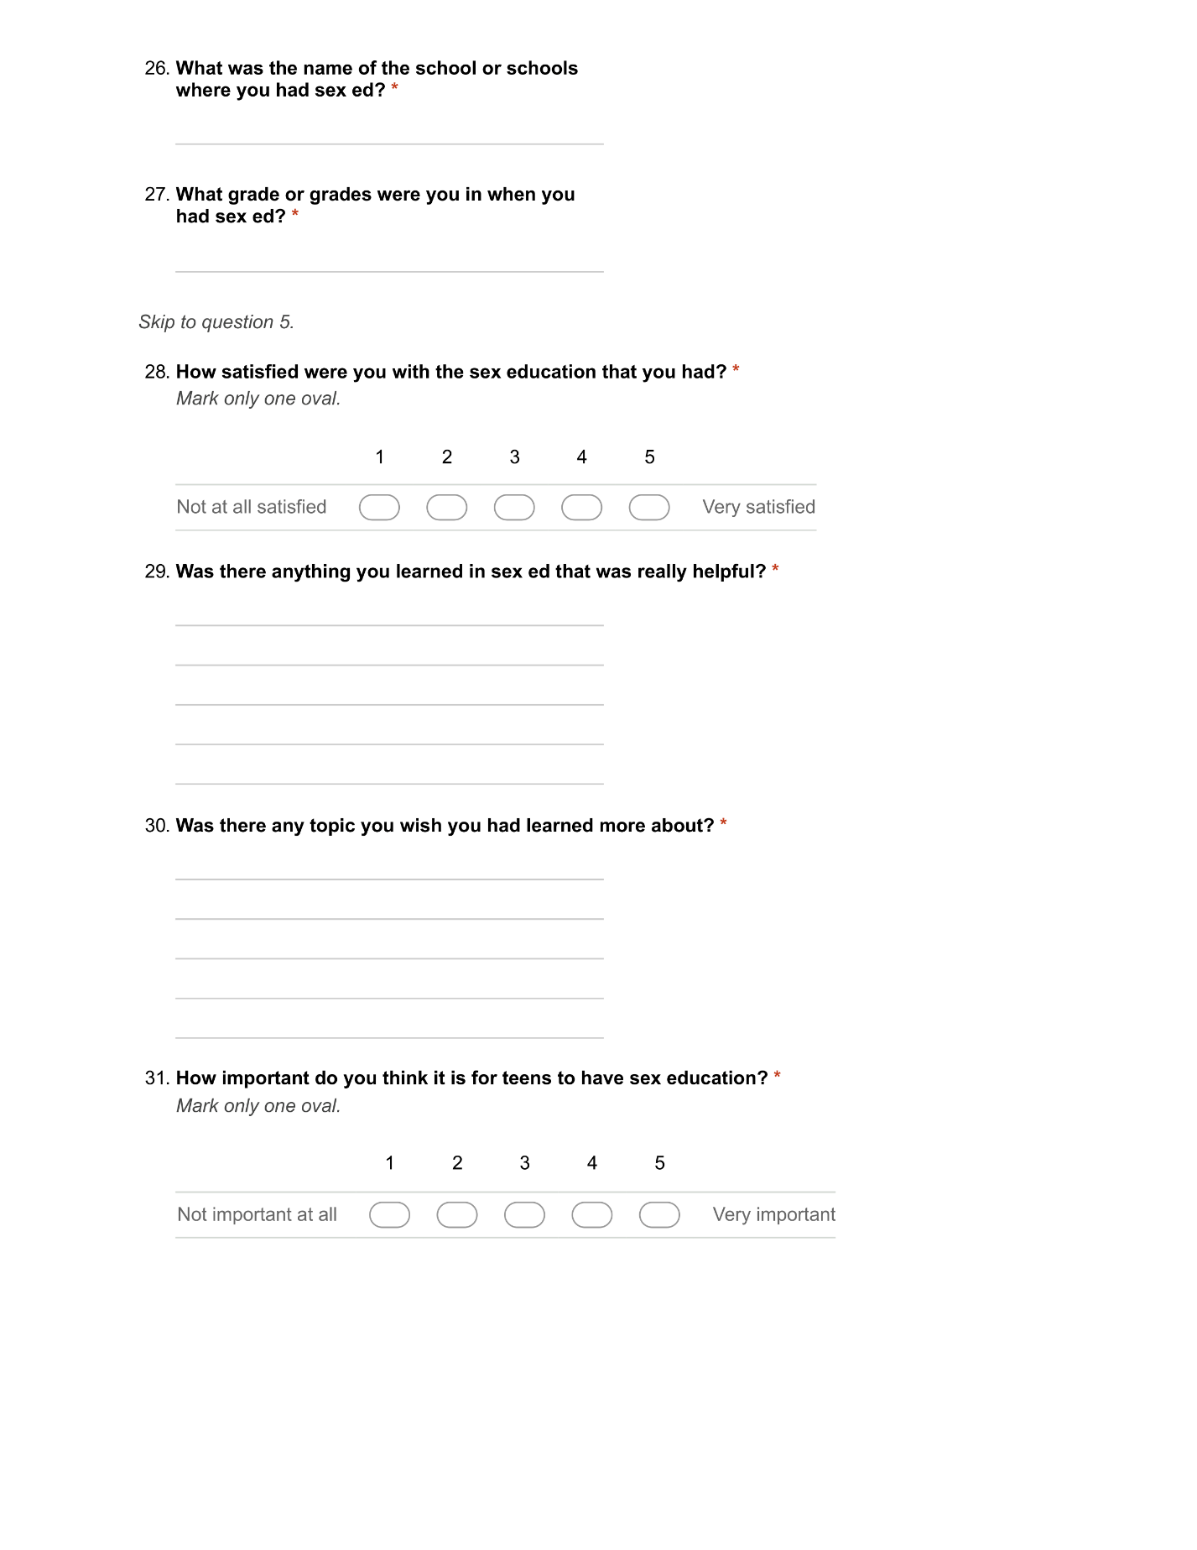



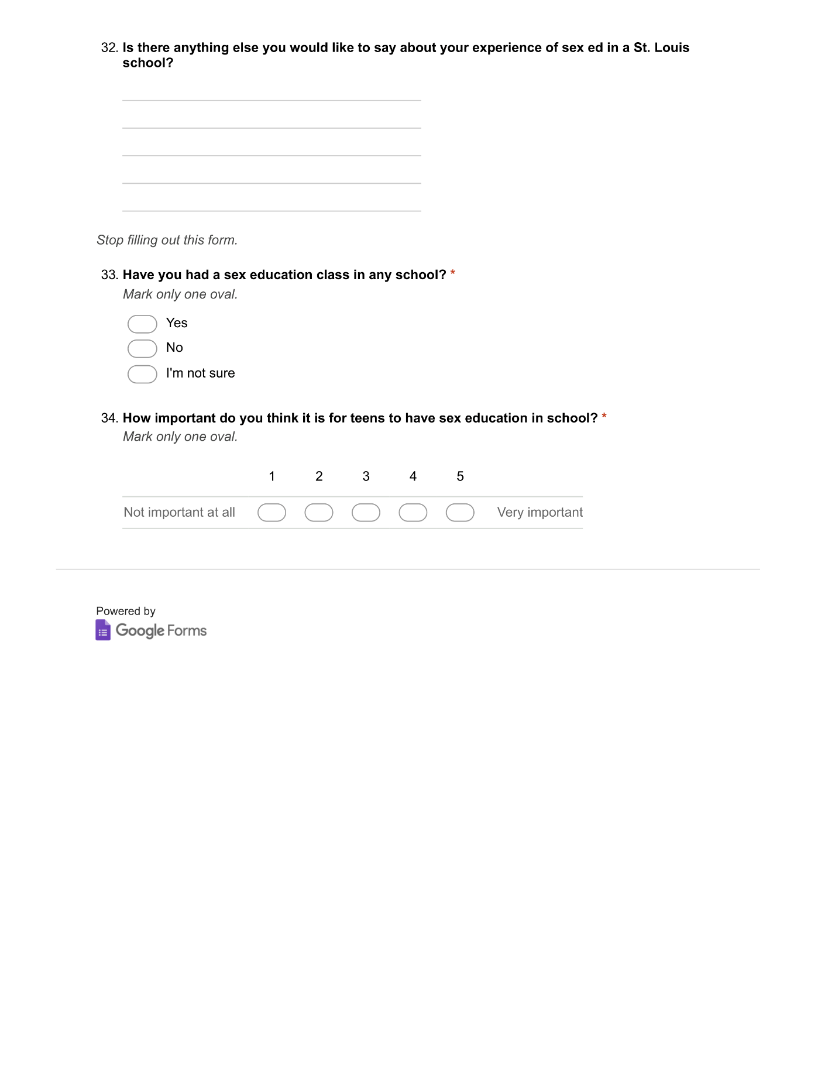

Table A1, YPSE Topics

Below is each topic included in the Youth Perspective on Sex Education (YPSE) survey, and if that topic was identified in the NSES, Missouri sex education statute (MSEP), or another source. Students were asked the degree to which they received instruction on each of these topics in a sex education class in a St. Louis-area public school.

|  |  |  |  |
| --- | --- | --- | --- |
| **Topic (in order as they appear in survey)** | **NSES** | **MO State Statute** | **Other** |
| **1. Consent** |  | X |  |
| **2. Healthy Relationships** | X |  |  |
| **3. Communication** |  |  | X |
| **4. Abstinence** |  | X |  |
| **5. Birth Control** | X | X |  |
| **6. How to use condoms** |  |  | X |
| **7. How Pregnancy Happens** | X | X |  |
| **8. The Consequences of Teen Pregnancy** |  | X |  |
| **9. Sexually Transmitted Diseases (STDs)** | X | X |  |
| **10. HIV/AIDS** | X | X |  |
| **11. LGBTQ+ Topics** | X |  | X |
| **12. Gender Identity** | X |  | X |
| **13. Reproductive Anatomy** | X | X |  |
| **14. Puberty** | X | X |  |
| **15. Online Safety** | X | X |  |
| **16. Personal Safety** | X | X |  |
| **17. Sexual Harassment** | X | X |  |
| **18. Sexual Violence** | X | X |  |
| **19. Consequences of Sexting** | X | X |  |
| **20. Human Trafficking** |  |  | X |

Table A2, Rationale for Additional Topics

Below is the rationale for inclusion of each YPSE topic that was not identified from the NSES or MSEP (See Table B1 for each topic in the survey).

|  |  |
| --- | --- |
| **Topic** | **Rationale for Inclusion** |
| **Communication** | Although communication is not listed as a Key Topic in the NSES, Interpersonal Communication is Standard 4 of the NSES’s National Health Education Standards: “Students will demonstrate the ability to use interpersonal communication skills to enhance health and avoid or reduce risk”  (Future of Sex Education Initiative, 2012, p. 11-17). Instruction on interpersonal communication is a vital component of healthy relationship and sexual consent education--both of which are also listed in the Missouri Sex Education Statute. Capturing data on the presence of education in interpersonal communication in sex education classrooms will provide useful insight into how well these two state mandates are being met. |
| **How to Use Condoms** | The Missouri State Statute mandates that schools shall teach “the latest medically factual information regarding both the possible side effects and health benefits of all forms of contraception, including the success and failure rates for the prevention of pregnancy and sexually transmitted diseases; or shall present students with information on contraceptives and pregnancy in a manner consistent with the provisions of the federal abstinence education law, 42 U.S.C. Section 710” (Mo. Rev. Stat. §170.015, 2015). Federal abstinence education law mandates that abstinence be presented as the expected standards for unmarried pupils and does not require discussion of methods for reducing the risk of pregnancy or sexually transmitted infections. Asking participants if they have received instruction on each contraceptive method, its efficacy rate, side effects, and benefits, would expand the survey to a prohibitive length. Inclusion of “how to use condoms” in the survey provides broader insight into the depth of information schools cover about contraception than would the topic “birth control” alone, without asking participants about all methods. If participants report being instructed on correct use of condoms, then a school would be classified as “abstinence-plus” and not “abstinence-only,” whereas a student could report being taught “birth control” and still be in a school with an abstinence-only policy. |
| **LGBTQ+ Topics** | The grades 6-8 learning indicators associated with the NSES topic “Identity” are: the ability to differentiate between sexual orientation, gender identity, and gender expression; identification of external influences on personal attitudes towards LGBTQ+ identities; and the ability to communicate respectfully regarding LGBTQ+ identities (Future of Sex Education Initiative, 2012, p.10). The word “identity” alone does not communicate the scope of this standard, and so it was modified for clarity. |
| **Gender Identity** | “Gender Identity” is included in addition to “LGBTQ+ Topics” due to the results of GLSEN’s (2019) National School Climate Survey Missouri State Snapshot, which found that transgender students are among the most vulnerable students, and likely to report feeling “unsafe” in Missouri schools (p. 2). |
| **Human Trafficking** | The 2016 landscape review of sex education in the St. Louis region, conducted by Coro Fellows Program in Public Affairs in partnership with TPPP and the National Council of Jewish Women (NCJW), included the topic “Human Trafficking” in their survey of sex education topics taught in regional school districts. For consistency, it is also included in this survey. |

|  |  |
| --- | --- |
| **School District** |  |
| **Students Enrolled** |  |
| **Policy URL** |  |
| **MSBA or "Other" Policy** | Missouri School Board Policy |
| **Notes** | Details pertaining to location of policy or materials analyzed if policy could not be located. |
| **Abstinence** | Abstinence is required to be covered in the policy, not if the policy is abstinence-only |
| **Anatomy & Physiology** |  |
| **CM, PR, SE** | Conflict Management, Personal Responsibility, Self Esteem. Identified in the MSEP. |
| **Cont.** | Contraception |
| **Consent** |  |
| **Consq. of Teen Pregnancy** | Consequences of Teen Pregnancy |
| **Consq. of Sexting** | Consequences of Sexting |
| **EP Consq. Adol. Sex** | Emotional and Psychological Consequences of Adolescent Sexual Activity. Identified in the MSEP. |
| **Gender Identity** |  |
| **Healthy Relationships** |  |
| **Human Trafficking** |  |
| **Laws Respons. Children** | Students must be made aware of the legal responsibility to children born outside of wedlock. Identified in MSEP. |
| **LGBTQ+ Topics** |  |
| **Online Safety** |  |
| **Personal Safety** |  |
| **PG & Repro.** | Pregnancy and Reproduction |
| **Pub. & Adolescent Dev.** | Puberty and Adolescent Development |
| **Sex. Harassment** | Sexual Harassment |
| **STI's & HIV** |  |
| **Medically + Factually Accurate** | Policy states that instruction on **contraception** must be medically and factually accurate |
| **Abstinence-Only** | Policy states that instruction on **contraception** must focus solely on abstinence as the preferred method for unwed teens in accordance with Federal abstinence-only laws. |
| **Abstinence-Only Optional** | Schools in the district may choose abstinence-only or medically and factually accurate **contraception** instruction. |
| **Meets NSES** | Policy meets the National Sexuality Education Standards |
| **Meets MSEP** | Policy meets the Missouri Sex Education Policy standards |

Table A3, SDSEP Matrix Topics

School District Policies or Curricula were analyzed in the SDSEP Matrix according to each of the variables listed in this table. See accopanying description where applicable.



Appendix B, Tables & Figures

Figure B1, Qualitative Analysis of YPSEQuestion:*“Is there anything else you would like to say about your experience with sex ed in a St. Louis-area public school?”*

Table B2 Sex Ed Topics Covered in St. Louis-Area Public School Districts’ Sex Education Policies

This chart shows the topics listed in the sex education policies of the St. Louis-area public school districts identified in the YPSE survey. Two school districts (Parkway and Webster Groves) did not have sex education policies available, so their healh curricula were analyzed instead.

